Communication Log for Staff
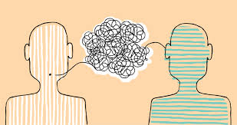

Child (use initials)_________________ Date:_________________ Staff:_______________

Please take 5 minutes after service to give a brief account of how the child did today.

Specific behavior observed: ____________________________________________________________________________________________________________________________________________________________________________________________________________________________________________
Possible triggers:
____________________________________________________________________________________________________________________________________________________________________________________________________________________________________________
How behavior was dealt with and was it successful? ________________________________________________________________________________________________________________________________________________________________________________________________________________________________________________________________________________________________________________________________________________________________________________________________________________________________________________________________________________________
Positive moments:
____________________________________________________________________________________________________________________________________________________________________________________________________________________________________________
Communication Log for Staff

Child (use initials)_________________ Date:_________________ Staff:_______________

Please take 5 minutes after service to give a brief account of how the child did today.

Specific behavior observed: ____________________________________________________________________________________________________________________________________________________________________________________________________________________________________________
Possible triggers:
____________________________________________________________________________________________________________________________________________________________________________________________________________________________________________
How behavior was dealt with and was it successful? ________________________________________________________________________________________________________________________________________________________________________________________________________________________________________________________________________________________________________________________________________________________________________________________________________________________________________________________________________________________
Positive moments:
____________________________________________________________________________________________________________________________________________________________________________________________________________________________________________

